**ORDER**

**DELICIOUS**

**PEACHES!**

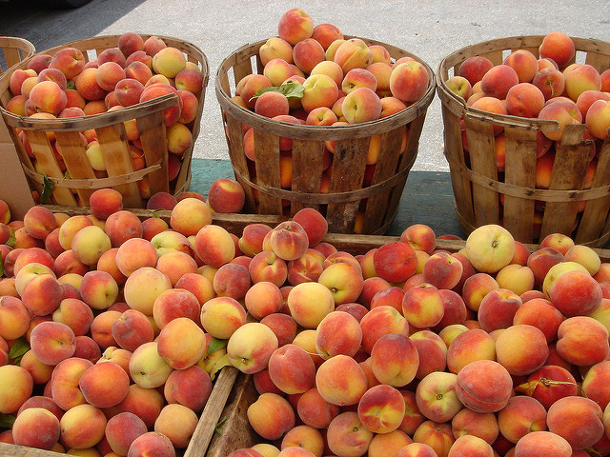

The Mercer County Farm Bureau will be selling fabulous southern Illinois peaches from Rendleman Orchard, located in Union County. The price for a 25 lb. box is $35.00 and we must have orders with payment by July 19th. We will contact you once we know the delivery date, it should be the first week of August with pick up at Gold Star, FS at 2004 State Highway 17, Aledo from 12 noon to 5pm. Peaches may be picked up there and quality cannot be guaranteed if peaches are not picked up immediately.

To order, please fill out the order form below and return it along with your payment to the address below. Additional order forms can be picked up at the Farm Bureau office at 206 SE 3rd Street, Aledo. Don’t miss out on these juicy Illinois delights! **Deadline to order is July 19th.**

---------------------------------------------------------------------------------------------------------------------------------------

Name: _______________________________________________________________

Address: _____________________________________________________________

Street City State Zip

Home Phone: _______________________ Cell Phone: _______________________

Email Address _________________________________________________________

_______ Boxes of Peaches @ $35.00 ea. = $ _________________

Please send this form along with payment to: Mercer County Farm Bureau, 206 SE 3rd Street, Aledo, IL 61231